TEMA+ Secretary :  ELTE BTK Atelier  1088 Budapest  Múzeum krt. 6-8.  Phone/fax: +361 485-5200/5234  E-mail:secretary@mastertema.eu  www.mastertema.eu | 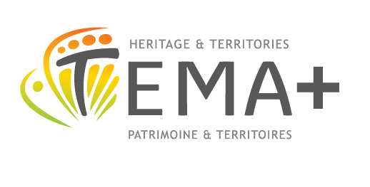

APPLICATION FORM
TEMA+ Erasmus Mundus Joint Master Course
European Territories: Heritage and Development
The complete scanned documentation
must be sent by e-mail to
Lilla ZÁMBÓ
TEMA+ Secretariat
Eötvös Loránd Tudományegyetem
Atelier
secretary@mastertema.eu

Deadline : June 30th 2018
Please note that incomplete documentations will NOT be taken into consideration. Shortlisted candidates must supply hard copies of the required documents.

Family name: First name(s):
Maiden name:
Date of birth:
Place of birth (city and country):
Citizenship: Gender: M F

Single Married Children (number, age)

If you are married and have children, would you like to bring your family ? yes no
Please note that this information will be used only in order to best prepare your stay in the hosting institution.

What is your current institution ?

Address:

Postal code: City: Country:
Telephone: Mobile: Fax:
E-mail: Personal website or Blog:
What is your current function :

What is your native language ?

Which language would you use during your stay in the hosting institution ?
English French

By which higher education institution do you want to be hosted?
Ecole des Hautes Etudes en Sciences Sociales of Paris (FR)
Charles University of Prague (CZ)
University of Catania (IT)
University of Laval, Québec (CA)

Do you have a disability, or a specific medical condition? yes no
If yes, please specify:
Please note that strict rules on confidentiality of data will be observed by the TEMA Consortium, and this information will be used only in order to best support you during your stay in the hosting institution.

Please indicate how you first heard of the TEMA+ Master Course:

DECLARATION
I confirm that, to the best of my knowledge, the information given in the application documentation is correct. I understand that any false or incorrect information will immediately cancel the application procedure.
I am aware that only complete application documentations can be submitted and that incomplete applications will not be processed.
I understand that the admission decision is definitive and is not subject to appeal.
I further declare that, to the best of my knowledge, no restrictions apply to my eligibility to reside in the country involved in my work within the TEMA+ Erasmus Mundus Master Course.

Date:

signature

Check-list of documents required for application :

Completed application form, signed and dated
CV in English or in French, with list of publications, including translations and list of taught courses
Motivation letter in English or in French (1 to 2 pages)
Work project in English or in French
Two samples of publication in English or in French
Two references
Copy of passport, with validity end date

FILLED IN BY THE PEDAGOGIC COUNCIL OF THE TEMA+
MASTER COURSE

Decision of the Pedagogic Council of the TEMA+ Master Course:

After examining the candidate’s application and the adequacy between his/her work project and the content of TEMA+ Master Course, the Pedagogic Council, based on the two references, have decided as follows:

 | ACCEPTED | REFUSED
If refused, please specify the reason:

Date and signature of Pedagogic Council members:

Stamp of TEMA+ Secretary:

