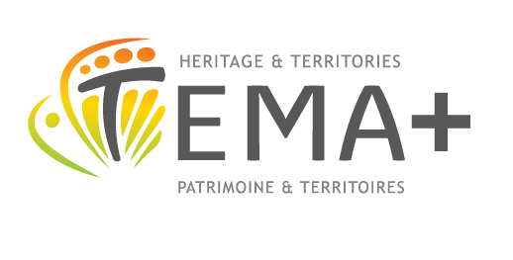
TEMA+ Secretary :
ELTE BTK Atelier
1088 Budapest
Múzeum krt. 6-8.
Phone/fax: +36 1 485-5200/5234
E-mail: secretary@mastertema.eu
http://www.mastertema.eu

REFERENCE

This reference is part of the application form for the TEMA+ European Territories: Heritage and Development Erasmus Mundus Joint Master Programme. The TEMA+ Pedagogic Council kindly ask you to fill in this form and transmit it in a signed and sealed envelope to the applicant, who will submit it attached to the application. Thank you for assisting us in our admission process.

Applicant
Family name: First name:
Citizenship:

Referee
Family name: First name:
Position/Affiliation:
Institution:
Telephone: Fax: E-mail:

How long have you known the applicant?

In what capacity have you known the applicant?

Please fill in the following table:

 | Excellent | Above average | Average | Below average | Unable to rate
Knowledge in area of Master TEMA
World knowledge
Ability to carry out independent research
Analytical ability
Reasoning skills
Oral communication skills
Written communication skills
Motivation
Openness
Social skills
Intercultural skills
Creativity

Would you recommend the applicant for the TEMA+ programme? yes no
Please indicate the reason:

Date :

signature & stamp

